**14 Creative Ways to Cook Eggs You May Not Have Heard Of Yet**



## There's no denying that eggs are one of the most versatile foods — and the classic methods of cooking them (frying, boiling, etc.) only scratch the surface of the countless ways you can prepare them!

So we rounded up 14 egg-cooking techniques — from slow cooker scrambles to red wine poached eggs — that are equal parts strange, practical, and delicious.

## 1. Make [poached](https://food52.com/recipes/17328-daniel-patterson-s-poached-scrambled-eggs) "scrambled" eggs.

[](https://img.buzzfeed.com/buzzfeed-static/static/2019-09/3/18/asset/9c80c7614c93/sub-buzz-253-1567537088-1.jpg) [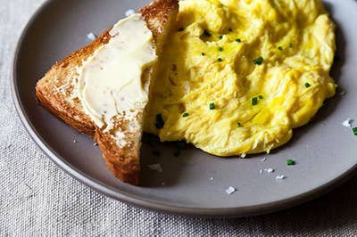](https://img.buzzfeed.com/buzzfeed-static/static/2019-09/3/19/asset/1a5cc6129278/sub-buzz-296-1567537216-1.jpg)

Stream uncooked eggs into gently simmering water and watch them transform into the fluffiest "scrambled" eggs you've ever seen. It sounds weird, but it works!

**Get the recipe:** [Daniel Patterson's Poached Scrambled Eggs](https://food52.com/recipes/17328-daniel-patterson-s-poached-scrambled-eggs)

## 2. Make a [sheet pan frittata](https://reciperunner.com/sheet-pan-spinach-tomato-ricotta-frittata/) that's perfect for meal prepping.

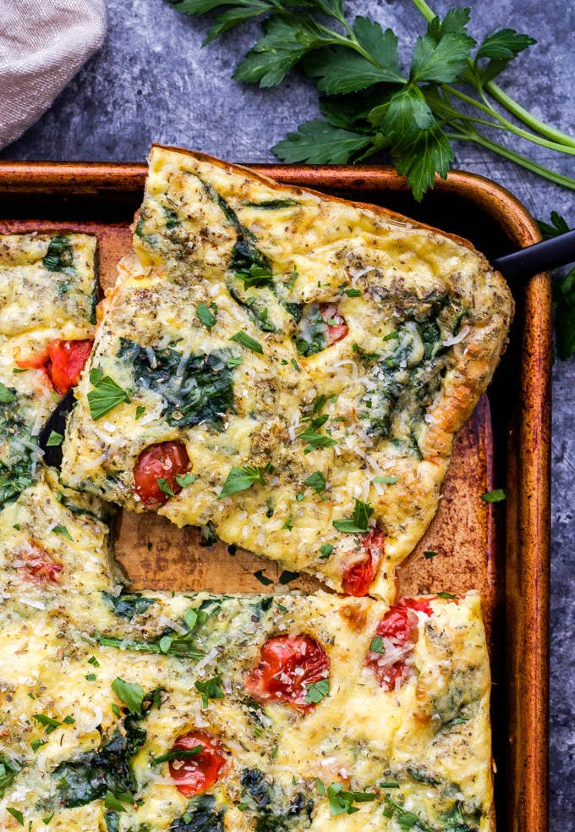

You can add just about any veggies you want to the base mixture depending on the season. Kale, bell peppers, and thinly sliced onions would all work well.

**Get the recipe:** [Sheet Pan Spinach Tomato Ricotta Frittata](https://reciperunner.com/sheet-pan-spinach-tomato-ricotta-frittata/)

## 3. Bake eggs [in mini muffin tins](https://fitfoodiefinds.com/how-to-bake-eggs-in-oven/#_a5y_p=3341932) and make breakfast sandwiches with them.

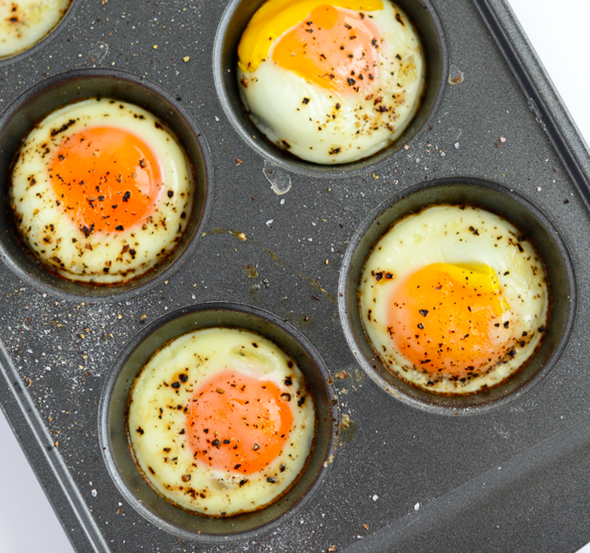

Serve these on top of [English muffins](https://www.allrecipes.com/recipe/6947/english-muffins/) or on [flaky biscuits](https://sugarspunrun.com/easy-homemade-biscuits/) for the ultimate grab-and-go DIY breakfast sandwiches.

**Get the recipe:** [Baked Eggs](https://fitfoodiefinds.com/how-to-bake-eggs-in-oven/#_a5y_p=3341932)

## 4. Cook an omelet [directly in a waffle iron](http://growingupgabel.com/waffle-omelet-recipe/) for a quick and unexpected breakfast.

[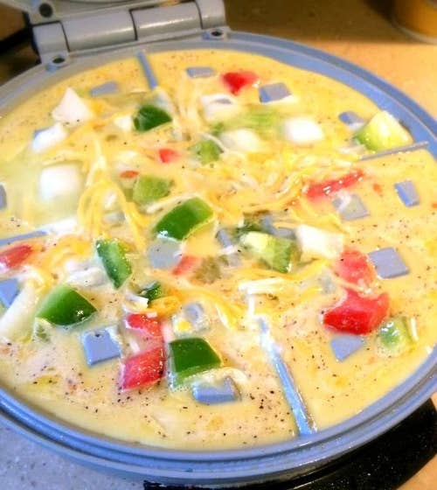](https://img.buzzfeed.com/buzzfeed-static/static/2019-09/3/18/asset/1231015214f3/sub-buzz-242-1567536908-1.jpg)

Pro tip: Cover these omelets with shredded cheese as soon as they come out of the waffle iron. You won't regret it.

**Get the recipe:** [Waffle Omelet](http://growingupgabel.com/waffle-omelet-recipe/)

## 5. Make insanely fluffy scrambled eggs [using an espresso steamer](https://www.facebook.com/FoodNetwork/videos/how-to-make-martha-stewarts-cappuccino-eggs/270438783641880/).

[Facebook: video.php](https://www.facebook.com/video.php?v=270438783641880)

Using the steamer wand of an espresso machine to scramble eggs might sound weird, but the gentle, moist heat keeps them from drying out. And besides, if Martha Stewart tells you to cook your eggs using an espresso steamer, you listen. ¯\_(ツ)_/¯

**Get the recipe:** [Espresso Scrambled Eggs](https://www.facebook.com/FoodNetwork/videos/how-to-make-martha-stewarts-cappuccino-eggs/270438783641880/)

## 6. Make perfect poached eggs by [pricking a tiny hole](https://www.thekitchn.com/julia-childs-simple-trick-for-perfect-poached-eggs-every-time-tips-from-the-kitchn-218202) in the shells with a pin.

[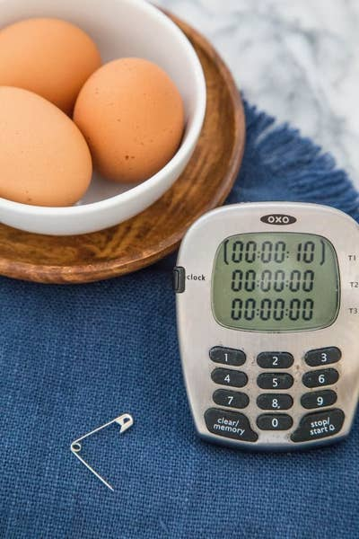](https://img.buzzfeed.com/buzzfeed-static/static/2019-09/3/18/asset/61f2308f3cdf/sub-buzz-201-1567535610-1.jpg)

[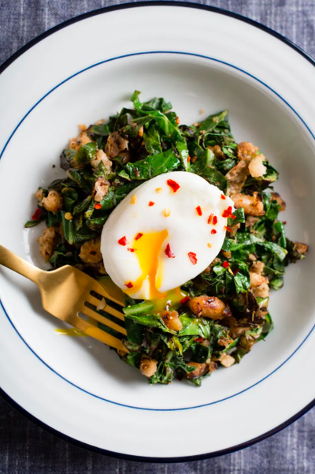](https://img.buzzfeed.com/buzzfeed-static/static/2019-09/3/18/asset/413bda739950/sub-buzz-221-1567535633-1.png)

Just use a sharp pin to prick a hole in the bottom side (i.e. the rounder side) of your eggs. This helps release the small air pocket that can sometimes cause boiled eggs to crack open when boiling. (This particular recipe — straight from Julia Child — also par-boils the poached eggs in their shells for 10 seconds before cracking them open. This helps firm up the whites just enough for them to keep their shape when being poached.)

**Get the recipe:** [Julia Child's Poached Eggs](https://www.thekitchn.com/julia-childs-simple-trick-for-perfect-poached-eggs-every-time-tips-from-the-kitchn-218202)

## 7. Poach eggs [in little plastic wrap pouches](https://www.buzzfeed.com/christinebyrne/plastic-wrap-poached-eggs?utm_term=.tpgbVJ5eb#.ugl3WZ1P3) to keep them nice and uniform...

[Facebook: video.php](https://www.facebook.com/video.php?v=1232756693404221)

Line a small bowl with plastic wrap, crack an egg into it, and tie the plastic wrap around it into a tight pouch. Then just poach the egg directly in the pouch so it holds its shape. Once cooked, snip the plastic wrap open, dry it off, and you have a perfectly poached egg.

**Get the recipe:** [Plastic Wrap Poached Eggs](https://www.buzzfeed.com/christinebyrne/plastic-wrap-poached-eggs?utm_term=.tpgbVJ5eb#.ugl3WZ1P3)

## 8. Or make a poached egg [in the microwave](https://www.onegoodthingbyjillee.com/microwave-poached-eggs/) in just one minute.

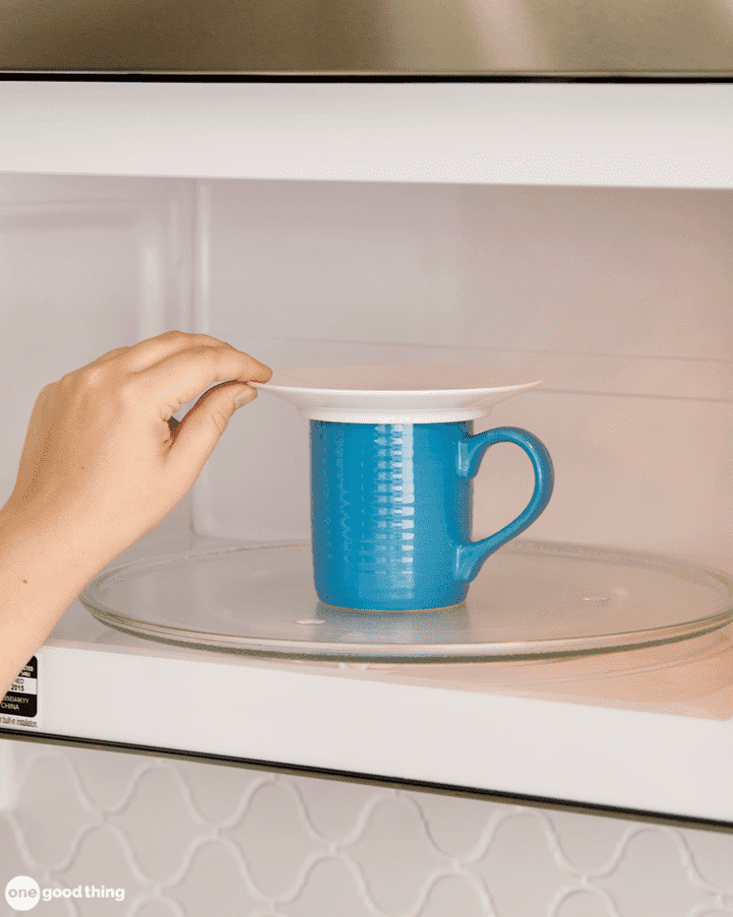This recipe recommends microwaving the egg for one full minute — but the cooking time will vary depending on your microwave, so keep an eye on it. You should also make sure to let the egg completely cool before cutting into it. The yolk is super hot and may explode.

**Get the recipe:** [Microwaved Poached Eggs](https://www.onegoodthingbyjillee.com/microwave-poached-eggs/)

## 9. [Cook your eggs](https://www.dessertfortwo.com/kale-on-toast-with-red-wine-poached-eggs/) in leftover red wine* to give them a stunning red color and subtle flavor.

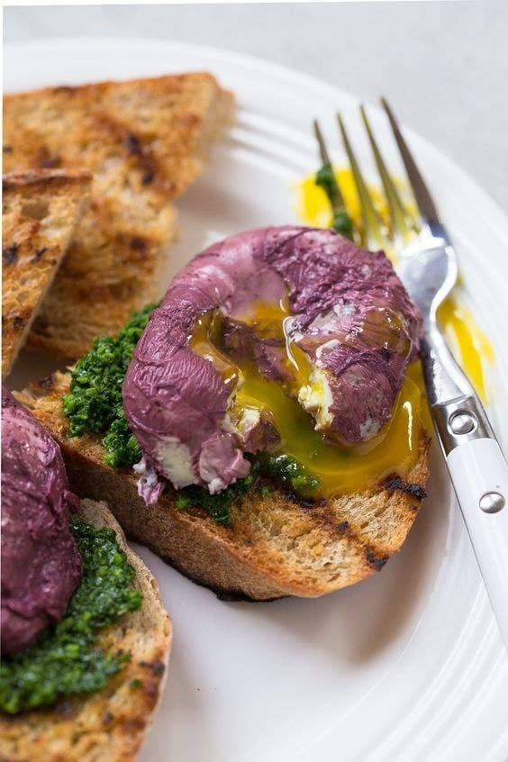

Perfect for serving over crusty bread or on English muffins for a fun twist on Eggs Benedict. (*We also never have leftover wine, so don't @ us!)

**Get the recipe:** [Red Wine Poached Eggs](https://www.dessertfortwo.com/kale-on-toast-with-red-wine-poached-eggs/)

## 10. Make an egg white omelet within a matter of seconds [in the microwave](https://kirbiecravings.com/microwave-egg-white-omelettes/).

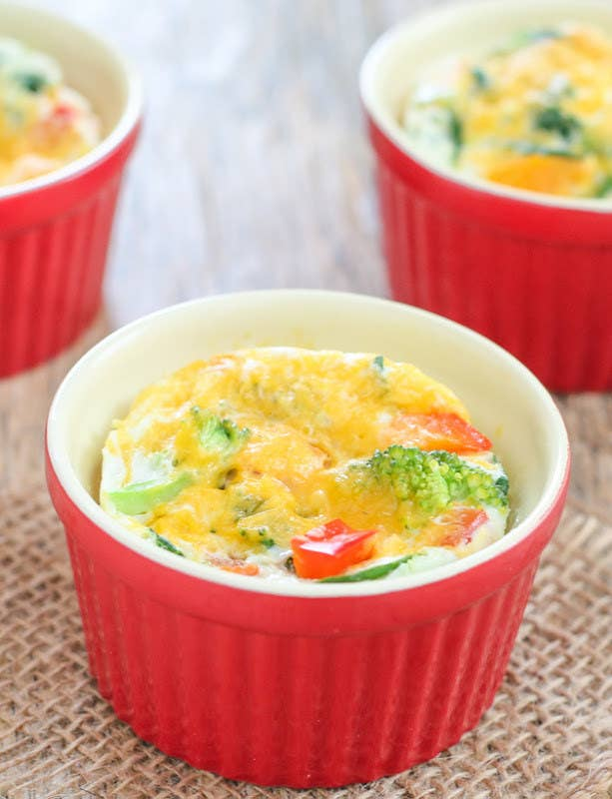

This recipe uses spinach, bell peppers, and broccoli to bulk up the omelets, but you can add pretty much any vegetables you have on hand.

**Get the recipe:** [Microwave Egg White Omelets](https://kirbiecravings.com/microwave-egg-white-omelettes/)

## 11. Batch cook a bunch of "hard-boiled" eggs [in the oven](https://unsophisticook.com/hard-boiled-eggs/)...

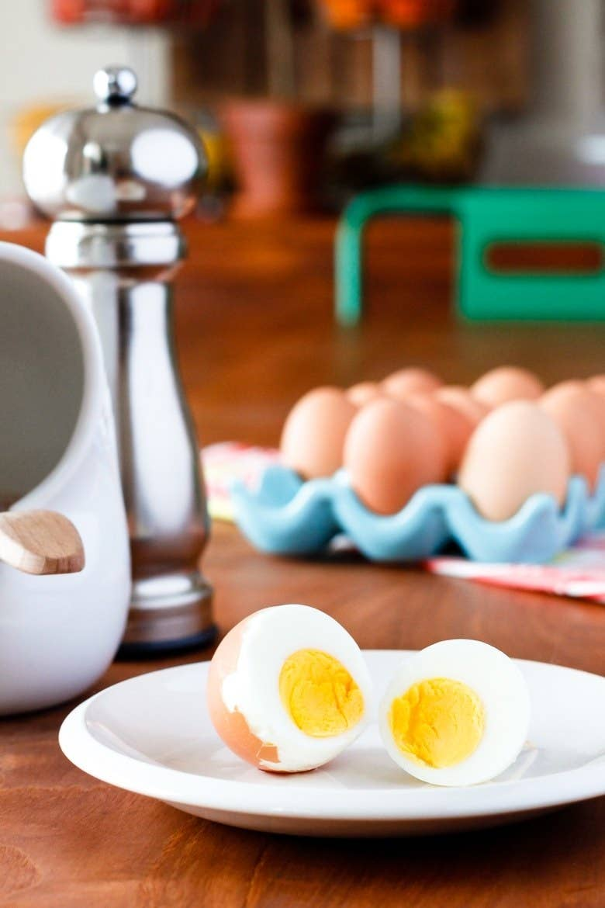

Just place a bunch of eggs in mini muffin tins, bake for 30 minutes, and transfer them into an ice bath. No boiling required!

**Get the recipe:** [Baked "Hard-Boiled" Eggs](https://unsophisticook.com/hard-boiled-eggs/)

## 12. Or make "hard-boiled" eggs by [steaming them](https://www.jessicagavin.com/how-to-hard-boil-eggs/).

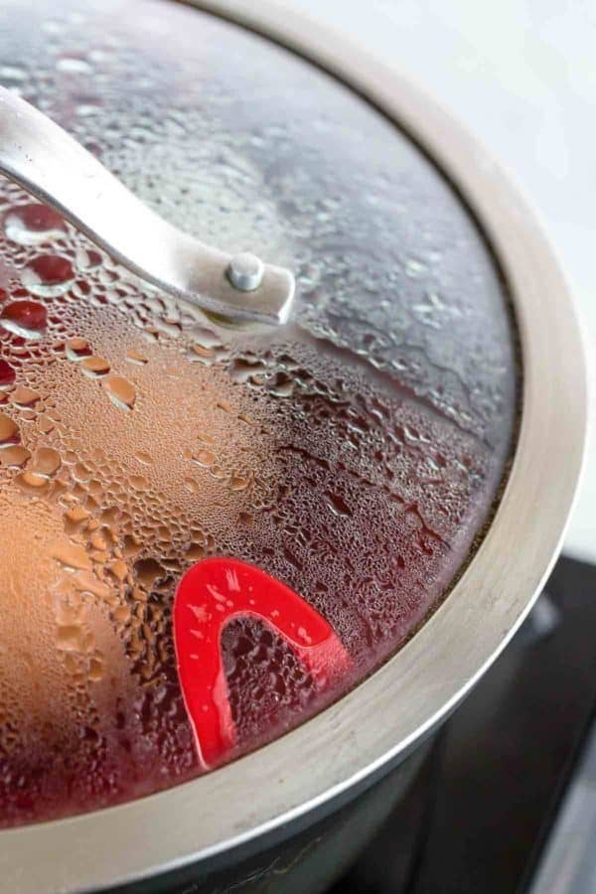

Thirteen minutes and a [steamer basket](https://www.amazon.com/OXO-Stainless-Steamer-Extendable-Handle/dp/B000HCBDF2/ref=sr_1_5?crid=28MT9FE2I6L8A&keywords=steamer+basket&qid=1567621312&s=gateway&sprefix=steamer+basket%2Caps%2C289&sr=8-5) is all you need to make perfect and easy-to-peel "hard-boiled" eggs.

**Get the recipe:** [Steamed "Hard-Boiled" Eggs](https://www.jessicagavin.com/how-to-hard-boil-eggs/)

## 13. Make sunny side up-style eggs by [baking them](https://www.familyfreshmeals.com/2018/01/how-to-cook-sheet-pan-eggs.html) on a sheet pan.

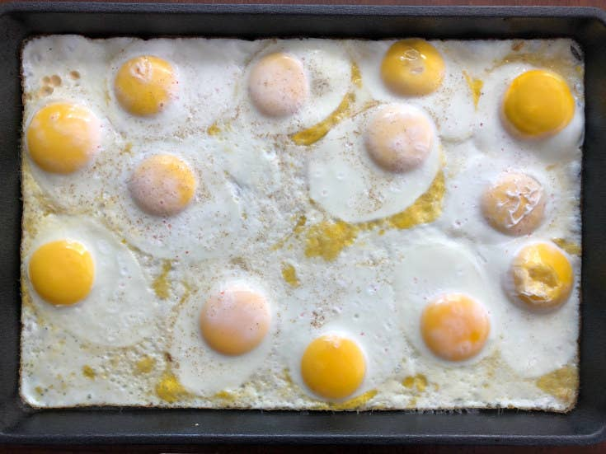

Pro tip: Make sure to use a clean and well-oiled sheet pan to prevent the eggs from sticking.

**Get the recipe:** [Sheet Pan Eggs](https://www.familyfreshmeals.com/2018/01/how-to-cook-sheet-pan-eggs.html)

## 14. Make a big batch of scrambled eggs [in the slow cooker](https://thefoodcharlatan.com/make-ahead-scrambled-eggs-recipe/).

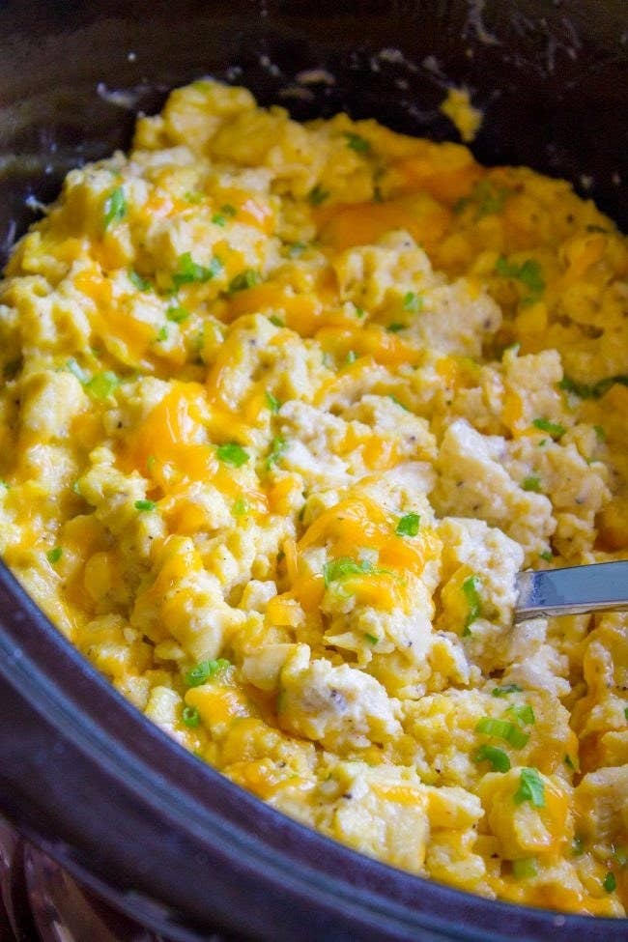The trick to keeping these slow cooker scrambled eggs soft? Cream cheese. It adds a rich texture that prevents them from drying out or becoming too firm.

**Get the recipe:** [Creamy Make-Ahead Scrambled Eggs](https://thefoodcharlatan.com/make-ahead-scrambled-eggs-recipe/)