5 millet street food recipes you must try for guilt free snacking

Life without street food becomes a monotonous series of bland food events. A splash of chutney, a dash of chaat masala and the sizzle of a fried chilly make things interesting.

Parents and grandparents have tried to convince us that street food is unclean, unhealthy and unfit for consumption.

But have they succeeded? Of course not.

Now I am not saying there is no truth to their claims. But there is a way to turn street food healthy too – [millets](https://karnival.com/search?q=millet&utm_source=thebetterindia.com&utm_medium=betterlife&utm_campaign=millet%20street%20food%20recipe-%2028%20Aug&utm_content=word).

Millet recipes have been extremely popular with those who have tried them, and we strongly recommend you give it a go too!

So here are five street food recipes with a healthy twist.

**1. Aloo Tikki**

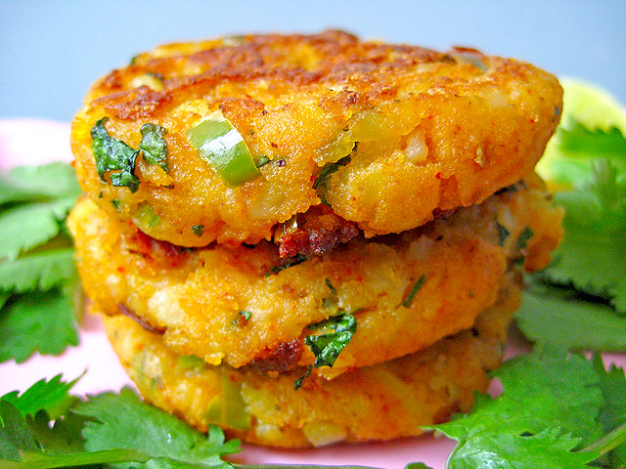Representative image. Source: [Soniya Goyal/ Flickr](https://www.flickr.com/photos/soniagoyal/25154602981" \t "_blank).

**Ingredients:**

**For the Tikki –**

2 medium potatoes (boiled, peeled and mashed)

1 small onion (finely diced)

½ cup finely chopped vegetables (onions, beans, peas, tomatoes, etc.)

4 tablespoon coriander leaves (chopped)

2 tablespoon raw [Kodo millet grain](https://karnival.com/search?q=kodo%20millet&utm_source=thebetterindia.com&utm_medium=betterlife&utm_campaign=millet%20street%20food%20recipe-%2029%20Aug&utm_content=word" \t "_blank)

2 teaspoon [coconut oil](https://karnival.com/search?q=coconut%20oil&utm_source=thebetterindia.com&utm_medium=betterlife&utm_campaign=millet%20street%20food%20recipe-%2029%20Aug&utm_content=word)

½ teaspoon chaat masala

[Salt](https://karnival.com/search?q=salt&utm_source=thebetterindia.com&utm_medium=betterlife&utm_campaign=millet%20street%20food%20recipe-%2028%20Aug&utm_content=word) to taste

**Green chutney –**

½ cup fresh coriander

½ cup mint leaves

4 teaspoon curds (For a vegan recipe, use coconut/ vegan curd)

1 teaspoon cumin powder

¼ teaspoon garlic paste

1 green chilli (deseeded and roughly chopped)

Salt to taste

**Tamarind chutney –**

1 cup tamarind water

¼ cup [jaggery](https://karnival.com/search?q=jaggery&utm_source=thebetterindia.com&utm_medium=betterlife&utm_campaign=millet%20street%20food%20recipe-%2028%20Aug&utm_content=word)

¼ teaspoon ground [cumin](https://karnival.com/search?q=cumin&utm_source=thebetterindia.com&utm_medium=betterlife&utm_campaign=millet%20street%20food%20recipe-%2029%20Aug&utm_content=word)

[Red chilli powder](https://karnival.com/search?q=chilli%20powder&utm_source=thebetterindia.com&utm_medium=betterlife&utm_campaign=millet%20street%20food%20recipe-%2029%20Aug&utm_content=word) to taste

[Salt](https://karnival.com/search?q=salt&utm_source=thebetterindia.com&utm_medium=betterlife&utm_campaign=millet%20street%20food%20recipe-%2028%20Aug&utm_content=word) to taste

**Directions:**

[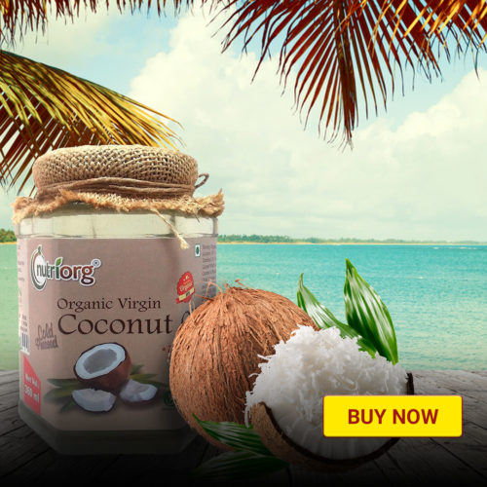](https://shop.thebetterindia.com/search?q=coconut%20oil&utm_source=thebetterindia.com&utm_medium=betterlife&utm_campaign=millet%20street%20food%20recipe-%2028%20Aug&utm_content=picture)

**For the tamarind chutney –**

* Combine all the ingredients in a saucepan and cook on a medium flame for about 10 minutes.
* Stir occasionally so it doesn’t burn.
* When the mixture is slightly reduced take it off the stove.
* Let it cool. (It’s a good idea to prepare this chutney first and the patties last)

**For the green chutney-**

* Put all the ingredients in a blender and blend until smooth.

**For the Tikki-**

* Grease your hands and start mixing all the ingredients in a mixing bowl. Make sure the mixture is even, and the spices are thoroughly spread.
* Divide into equal portions (about eight)
* Press gently to form patties. Meanwhile, heat a pan and grease it lightly with oil.
* Shallow fry the patties till they turn golden brown on each side.
* Remove from the pan and set aside.

When the Tikki and chutney are ready, arrange the patties on plates. Add the chutney according to taste and garnish with chopped onion and coriander and Sev.

Your millet Aloo Tikki is ready!

**2. Finger Millet Paneer Paniyaram/ Paddu**

[**https://youtu.be/CXc8-wpOGKk**](https://youtu.be/CXc8-wpOGKk)

**3. Millet Bhel**

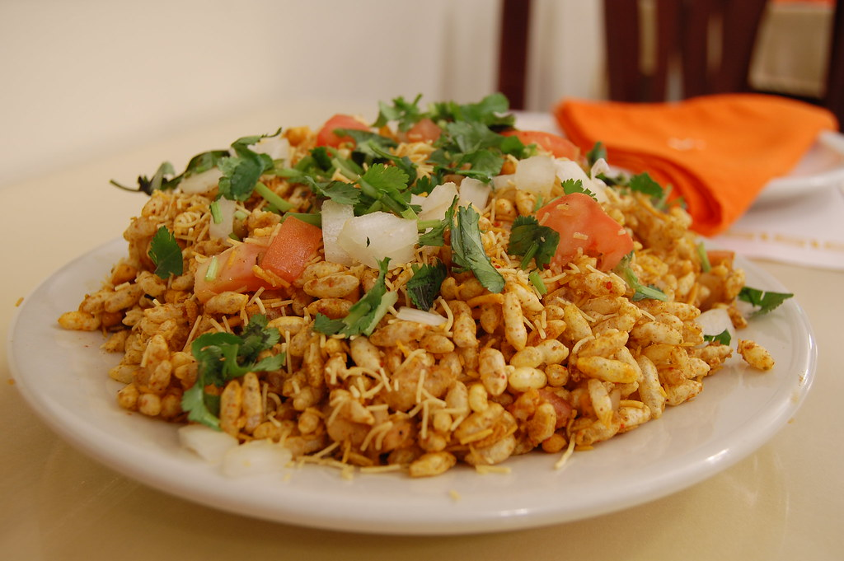Representative image. Source: stu\_spivack/ Flickr.

**Ingredients:**

4 potatoes (boiled and diced)

2 onions (chopped)

2 tomatoes (chopped)

3 cups puffed rice flakes

1 cup mix millet flakes

1 cup ragi flakes

½ cup peanuts (roasted)

½ cup amaranth and brown rice Namkeen

4 tablespoon lime juice

3 tablespoon [moringa leaves powder](https://karnival.com/search?q=moringa+leaves+powder)

3 tablespoon black sesame

3 tablespoon green chutney (recipe shared above)

2 tablespoon chaat masala

2 tablespoon green chillies

A handful of fresh coriander

**Directions:**

[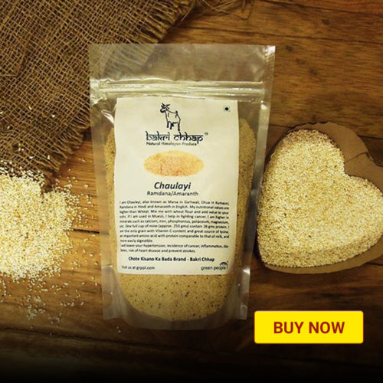](https://shop.thebetterindia.com/search?q=millet&utm_source=thebetterindia.com&utm_medium=betterlife&utm_campaign=millet%20street%20food%20recipe-%2028%20Aug&utm_content=picture)

* In a mixing bowl, add the mixed millets, ragi flakes and puffed rice flakes. Mix well.
* Add the roasted peanuts, amaranth and brown rice namkeen. Mix again.
* Sprinkle chaat masala and black sesame.
* When adequately mixed, add the potatoes, tomatoes, onions, lime juice and green chillies.
* Add the moringa powder and green chutney. Mix well.
* Garnish with coriander leaves.

**4. Millet Momos**

[**https://youtu.be/essBR1B4JgE**](https://youtu.be/essBR1B4JgE)

**Replace wheat flour with millet flour of your choice.**

**5. Millet Dosa**

[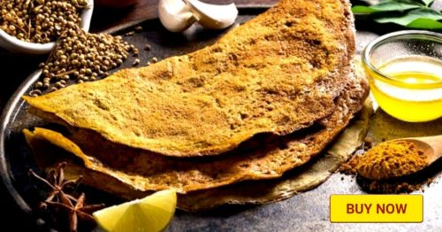](https://shop.thebetterindia.com/search?q=millet%20dosa&utm_source=thebetterindia.com&utm_medium=betterlife&utm_campaign=millet%20street%20food%20recipe-%2028%20Aug&utm_content=picture)

The easiest way to whip up a millet dosa is with the [ready-to-make batters](https://karnival.com/search?q=millet%20dosa&utm_source=thebetterindia.com&utm_medium=betterlife&utm_campaign=millet%20street%20food%20recipe-%2029%20Aug&utm_content=word). All you have to do is heat up a pan, grease it with a teaspoon of oil and add some batter, as per your preference.

Flip the dosa, cook on both sides. When both sides are light brown, the dosa is done.

Pair the dosa with some [organic pickle](https://karnival.com/search?q=pickle&utm_source=thebetterindia.com&utm_medium=betterlife&utm_campaign=millet%20street%20food%20recipe-%2029%20Aug&utm_content=word).