## **Cake needs no occssion. 5 vegan cake recipes to satisfy your sweet tooth guilt free**

## Vegan Vanilla cake:

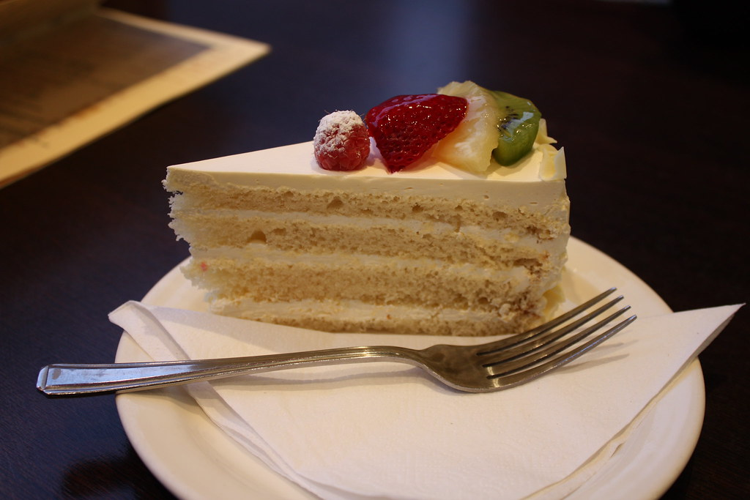

Let’s start with the universally-loved vanilla. Some may mistake its flavour for being too plain, but the cake is anything but ‘vanilla’ – if you get my drift. Let’s get started.

**Ingredients:**

**For the cake:**

220 gm of all-purpose flour  
240 ml of soy milk  
200 gm [vanilla sugar](https://shop.thebetterindia.com/search?q=vanilla+sugar)  
80 ml vegetable oil

1 tablespoon [apple cider vinegar](https://shop.thebetterindia.com/search?q=vinegar&utm_source=thebetterindia.com&utm_medium=betterlife&utm_campaign=vegan%20cake%20recipe-%2020%20Aug&utm_content=inline)  
1 teaspoon of vanilla extract  
1 teaspoon baking soda  
½ teaspoon [salt](https://shop.thebetterindia.com/products/sea-salt-350gms?_pos=1&_sid=30606fb4a&_ss=r&utm_source=thebetterindia.com&utm_medium=betterlife&utm_campaign=vegan%20cake%20recipe-%2020%20Aug&utm_content=inline)

**For the vanilla frosting:**

450 gm of vanilla sugar  
4 tablespoon soy milk  
3 tablespoon vegan butter  
1 teaspoon vanilla extract

**Directions:**

* Sift the flour into a mixing bowl and add the sugar, baking soda and salt. Mix well. Simultaneously, preheat the oven to 180° C.
* Once done, add the milk, vanilla extract, oil and vinegar and whisk it all together. A hand-whisk works perfectly.
* Grease two cake tins (about 7 inches each) with coconut or vegetable oil. If you have them, cut parchment papers into circles to fit the bottom of the pans. If not, ensure that the tin bottoms are greased well.
* Divide the batter between the two tins and bake for 30 minutes.
* Do a stick test. Once baked evenly, take out the cakes and let them cool.

In the meantime, let’s begin with the frosting.

Directions for frosting:

* Mix the vanilla sugar, butter, vanilla extract and half of the milk in a mixing bowl. Using an electric mixer, whisk it well. Keep adding the milk as you whisk. Stop when the mixture is smooth and creamy.
* Once your cake has cooled down completely, spread the frosting on one layer. Place the second layer on top of this and spread the frosting on the top and the sides.
* Decorate with fresh fruit, chocolate, cherries or not. Voila! Your cake is ready to be cut and eaten!

## Vegan Apple Cake

Easy to make and delicious to the taste, this apple cake is the perfect vegan dessert. Here’s the recipe.

## Vegan Chocolate Cake

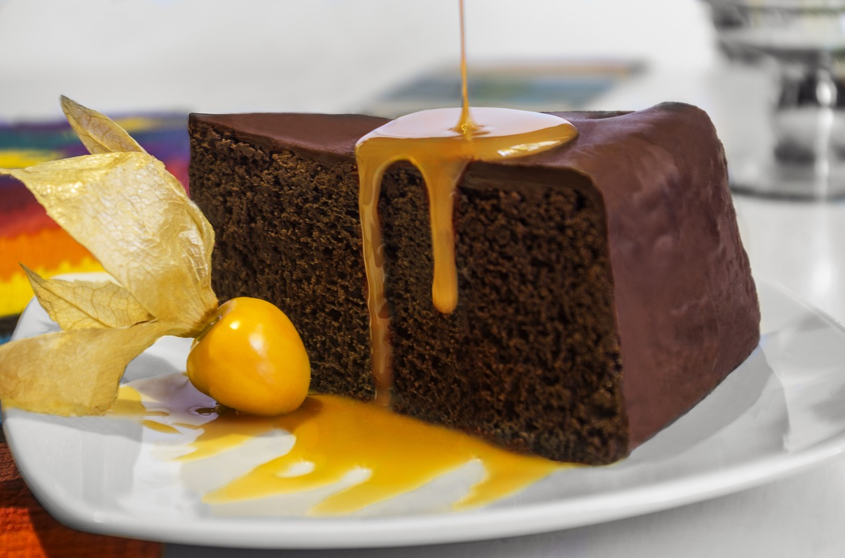

Who doesn’t love chocolate? The only thing better than chocolate is a chocolate cake. And that’s all the introduction this magnificent cake needs.

**Ingredients:**

2 cups of all-purpose flour  
1 and ½ cups of hot water  
1 cup of [vanilla sugar](https://shop.thebetterindia.com/products/green-vanilla-sugar?_pos=1&_sid=e0e0d1e6d&_ss=r)  
¾ cups of cocoa powder  
¼ cup + 2 tablespoons of vegetable [oil](https://shop.thebetterindia.com/search?q=oil&utm_source=thebetterindia.com&utm_medium=betterlife&utm_campaign=vegan%20cake%20recipe-%2020%20Aug&utm_content=word)  
1 ½ teaspoon of baking powder  
1 ½ teaspoon of espresso powder  
1 teaspoon of white vinegar  
½ teaspoon of salt

**Directions:**

* Start by preheating the oven at 180°C and greasing an 8-inch pan with vegetable oil (add parchment paper at the bottom if you have it). At the same time, mix the flour, baking soda, cocoa powder, espresso powder and salt.
* In another bowl, mix the hot water, sugar, vegetable oil and vinegar.
* Start adding the dry mixture into the wet mix. Make sure that you mix both till there are no lumps left. Do not overmix in a hurry!
* Once you get a uniform consistency, pour the batter in the cake tin and bake for 30 minutes.
* Do a stick test after 30 minutes. If it not done, then pop it in the oven for another 10 minutes.

When your cake is ready, spread dark chocolate or frosting over it. [You can also try our range of flavoured butter to spread over the delicious cake](https://shop.thebetterindia.com/search?q=butter&utm_source=thebetterindia.com&utm_medium=betterlife&utm_campaign=vegan%20cake%20recipe-%2020%20Aug&utm_content=inline)

## Vegan Carrot Cake

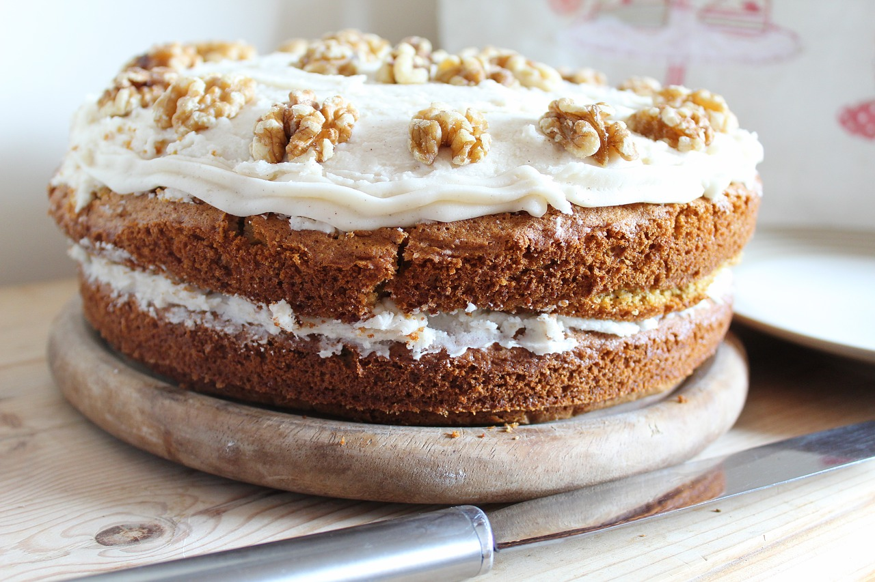

What’s up, doc? Ready for some carrot cake?

**Ingredients:**

300 gm carrots (grated)  
300 ml milk of your choice  
375 gm all-purpose flour  
175 gm [vanilla sugar](https://shop.thebetterindia.com/products/green-vanilla-sugar?_pos=1&_sid=e0e0d1e6d&_ss=r)  
125 ml [vegetable oil](https://shop.thebetterindia.com/search?q=oil&utm_source=thebetterindia.com&utm_medium=betterlife&utm_campaign=vegan%20cake%20recipe-%2020%20Aug&utm_content=word)  
70 gm walnuts (chopped)  
1 teaspoon vanilla essence  
2 teaspoons baking powder  
2 teaspoons ground cinnamon  
1 ½ teaspoon baking powder  
1 teaspoon ground nutmeg  
1 teaspoon ground ginger  
Vegan cream cheese frosting  
½ teaspoon salt

**Directions:**

* Preheat the oven to 180°C and grease two 8-inch round cake tins. In a bowl, mix the oil, sugar and vanilla and start whisking. When the sugar dissolves, add in the milk as well.
* In the same bowl, sift in the flour, baking powder, baking soda, cinnamon, ginger, nutmeg and salt.
* When mixed well, add in the walnuts and the carrots.
* Once you get a perfect consistency, divide the batter evenly between the two tins.
* Pop them in the oven and cook for 25 minutes (you already know the rule of the stick-test).
* Take out the cake and let it cool.
* Apply a layer of frosting on one of the cakes, place the second layer on top of it and spread frosting on the top layer.

You can decorate the cake with walnuts ([Here’s where you can purchase them organic](https://shop.thebetterindia.com/search?q=walnut&utm_source=thebetterindia.com&utm_medium=betterlife&utm_campaign=vegan%20cake%20recipe-%2020%20Aug&utm_content=inline)). A trail mix also complements the cake just as well. [Purchase the authentically organic kind, here](https://shop.thebetterindia.com/search?q=trail%20mix&utm_source=thebetterindia.com&utm_medium=betterlife&utm_campaign=vegan%20cake%20recipe-%2020%20Aug&utm_content=inline).

## Vegan Red Velvet Cake

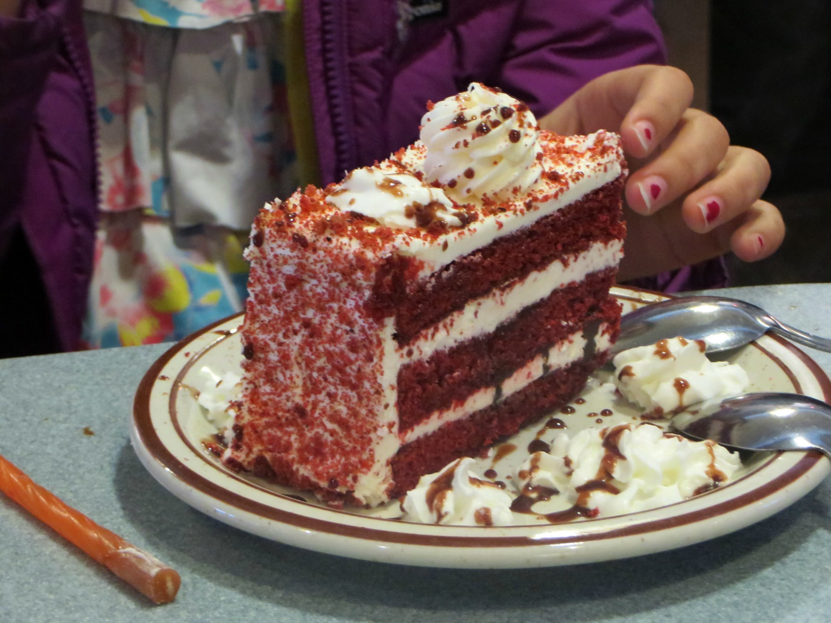

Rich, flavourful and perfect for a post-dinner dessert, the red velvet cake has taken connoisseurs by storm. And now you can bake it in a vegan version right at your home! Here’s how:

**Ingredients:**

**For the cake:**

3 cups of all-purpose flour  
1 ½ cup of [vanilla sugar](https://shop.thebetterindia.com/products/green-vanilla-sugar?_pos=1&_sid=e0e0d1e6d&_ss=r)  
½ cup of vegan butter (at room temperature)  
½ cup of [vegetable oil](https://shop.thebetterindia.com/search?q=oil&utm_source=thebetterindia.com&utm_medium=betterlife&utm_campaign=vegan%20cake%20recipe-%2020%20Aug&utm_content=word)  
½ cup of applesauce  
4 tablespoons of [organic cocoa powder](https://shop.thebetterindia.com/search?q=cocoa%20powder&utm_source=thebetterindia.com&utm_medium=betterlife&utm_campaign=vegan%20cake%20recipe-%2020%20Aug&utm_content=inline)  
2-3 tablespoons of vegan red dye ([or beetroot powder which you can get here](https://shop.thebetterindia.com/search?q=beetroot%20powder&utm_source=thebetterindia.com&utm_medium=betterlife&utm_campaign=vegan%20cake%20recipe-%2020%20Aug&utm_content=inline))  
1 tablespoon of baking powder  
1 teaspoon of white vinegar  
½ teaspoon of salt

**For vegan buttermilk:**

1 ¼ cups unsweetened milk of your choice  
2 teaspoons of [apple cider vinegar](https://shop.thebetterindia.com/search?q=vinegar&utm_source=thebetterindia.com&utm_medium=betterlife&utm_campaign=vegan%20cake%20recipe-%2020%20Aug&utm_content=word)

**For the frosting, refer to the vanilla cake recipe.**

**Directions:**

**Vegan Buttermilk:** Mix the milk and vinegar. Set aside to let it curdle.

**Cake:**

* Start by preheating the oven at 180°C and greasing two 8-inch pans with vegetable oil (and parchment papers at the bottom if you have it). At the same time, mix the flour, baking soda, cocoa powder and salt.
* In another bowl, whisk the butter and sugar. When it becomes smooth, mix the vegetable oil, applesauce, vanilla and white vinegar. Mix it well, so it has no lumps. Now add the beetroot powder (or red dye).
* If you are using an electric mixer, keep the speed on low and add the dry ingredients and the buttermilk (take turns to add them to avoid lumps. Don’t add the dry mix and the buttermilk all at once.
* When the mixture is smooth and even, your batter is done. Pour the batter in equal quantities in the two pans and put them in the oven.
* Let it bake for 35-40 minutes. If the stick test shows your cake is done, let it cool.

Spread the frosting evenly on one of the layers, add the second layer and repeat. Garnish, decorate and serve!