Egg Salad Stuffed Avocado

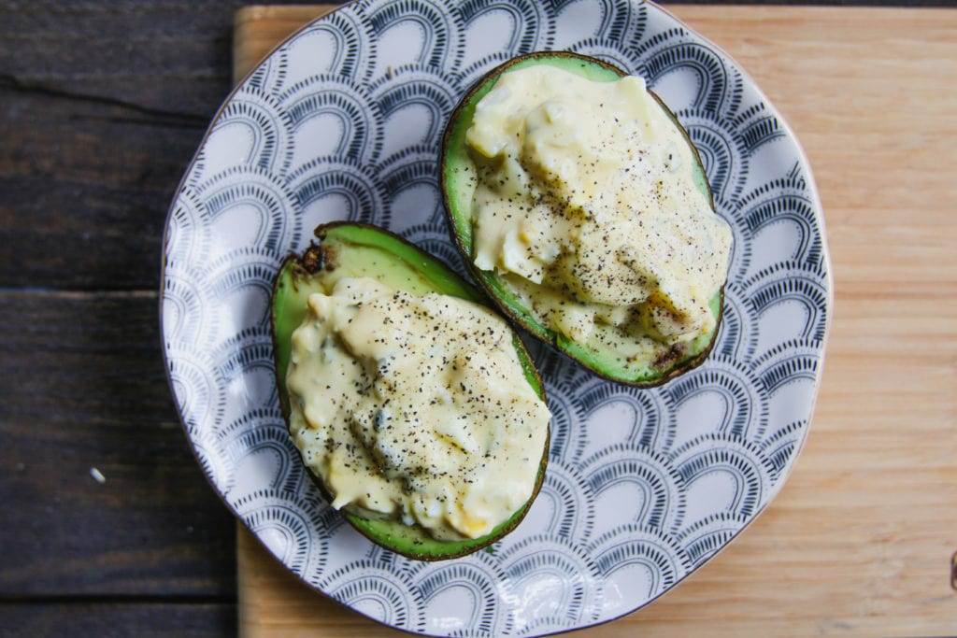

I love recipe mashups. And this is definitely one of them. Whether you need a quick lunchtime recipe or a snack that will keep you full until dinner, this egg salad stuffed avocado will do the trick.

Egg salad is an easy, high protein recipe you can whip up. But if you’re strict paleo, you’ve got to use the right kind of mayo. Traditional mayonnaise, like the Hellmann’s you can find in the store, is far from having the best ingredients. In fact, its primary ingredient is soybean oil.

Since paleo stays away from [all things soy](https://ultimatepaleoguide.com/soy-paleo/), that is off the table. But don’t worry, you can make your very own paleo mayo at home. And it’s actually pretty easy as long as you have the right tools. An immersion blender is going to be your best friend here. Not to mention, making your own is so incredibly cheap.

If you just don’t have the time or energy for that (hey, no judgment), there’s actually some paleo-friendly mayos on the market. Our favorite is [Primal Kitchen’s Avocado Oil Mayo](https://amzn.to/2LbH4vZ).

Once you have all of your ingredients, this recipe is literally the easiest. You’re going to rough chop your eggs and mix it up with the relish and mustard.

After that, slice your avo in half and scoop out half the flesh on each side using a spoon.

You’re going to put the avocado into the bowl with the eggs and condiments. But don’t throw away the avocado shells just yet! You’re going to need those in a second.

After everything is mashed up and seasoned to your tasting, spoon the egg salad mixture back into the half-empty avocado shells.

Voila. There you have your egg salad stuffed avocado.

Enjoy!

### Ingredients

* 2 hard boiled eggs
* 1 tablespoon Paleo mayonnaise
* 1 tablespoon relish
* 1 teaspoon Dijon mustard
* 1 avocado
* Sea salt and fresh ground pepper to taste

### Instructions

1. Rough chop the eggs and add to a bowl with the relish, mayo, and mustard.
2. Cut the avocado in half and remove the pit. Scoop half the flesh out of each side and add to the bowl with the eggs.
3. Mash well, and season with salt and pepper.
4. Spoon into the avocado shells and serve.