**KETO BLUEBERRY BREAD**

This low carb and keto-friendly blueberry bread is topped with a lemon glaze. It is an easy quick bread recipe that doesn’t even need a mixer.

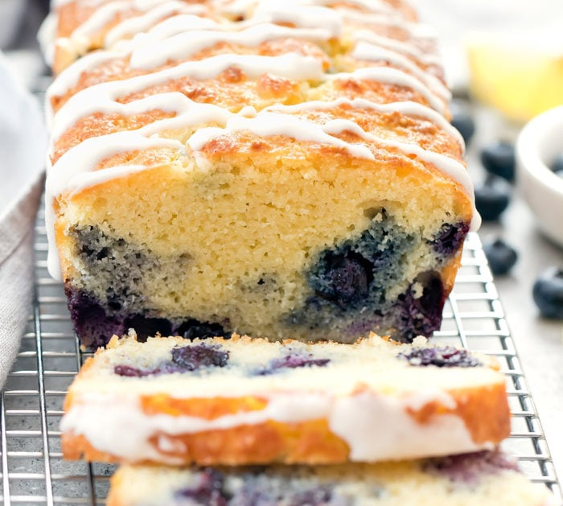

I love quick bread recipes. Just mix a few ingredients together and into the oven it goes and the outcome is a delicious, fluffy cake bread.

## INGREDIENTS

* eggs
* butter
* heavy cream
* vanilla
* superfine almond flour
* coconut flour
* baking powder
* erythritol
* blueberries

Regular flour is substituted with almond flour and coconut flour. I prefer almond flour as a flour substitute. However, coconut flour is also needed to give this bread height and fluffiness.

I like my blueberry bread packed with blueberries. However you can reduce the amount of blueberries used if you wish to cut the carb count further.

## HOW TO MAKE KETO BLUEBERRY BREAD

* First, whisk together all the liquid ingredients in one bowl.
* In a separate bowl, whisk together the dry ingredients.
* Add the dry ingredients into the wet and whisk until completely combined.
* Gently fold in the blueberries.
* Pour the batter into a loaf pan and bake for about 45 minutes or until done.

## LEMON GLAZE

This easy glaze comes together in just a few minutes. Fresh lemon juice, heavy cream and powdered erythritol are whisked together until smooth. The glaze is quite sweet so I prefer to just drizzle it over the bread rather than cover it completely.