**LEMON GARLIC RICE**

a spicy, tangy plate of Lemon Garlic Rice is heaven itself, and it’s super easy to make with just nine ingredients. Vegan, gluten-free and can be soy-free or nut-free.

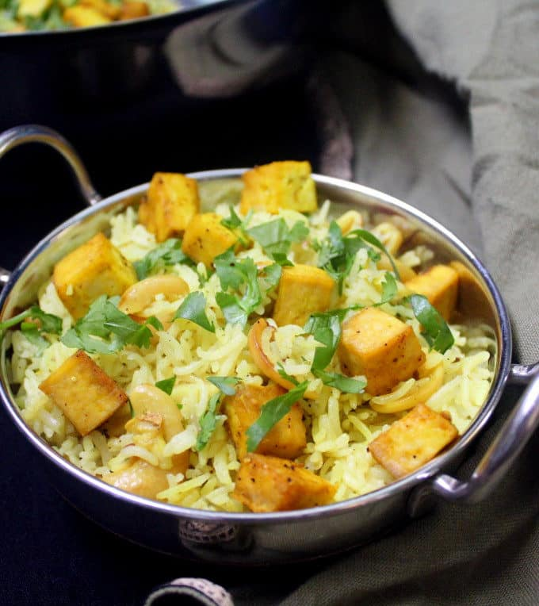

### Ingredients

* 1.5 cups [basmati rice](https://amzn.to/2ICMHBJ) (soaked for 30 minutes with enough water to cover by two inches. Drain and rinse a couple of times before using in recipe.)
* 1 tsp [vegetable oil](https://amzn.to/2FCQ389)
* 1 tsp [cumin seeds](https://amzn.to/2TjcSSd)
* 2 tbsp [cilantro](https://amzn.to/2CnObgI) (chopped)
* 1/2 tsp [turmeric](https://amzn.to/2OumzvG)
* 1/4 cup [raw cashews](https://amzn.to/2r4ip2J)
* 12 medium to large cloves [garlic](https://amzn.to/2WW5hM5) (smashed, peeled and then sliced)
* 1/3 cup lemon juice
* Zest of one lemon
* 16 oz [baked tofu cubes](https://holycowvegan.net/how-to-marinate-and-bake-tofu-for-indian-dishes/)
* Salt and ground black pepper to taste

### Instructions

* Heat the oil and add the cumin seeds. When they start to darken, add the cilantro and turmeric and stir for a few seconds to mix. Add the garlic and cashews and stir-fry until the garlic begins to turn a light blonde.
* Add the drained rice along with salt and ground black pepper to taste and cook, stirring, until the rice starts to turn opaque.
* Add the lemon juice and zest and two cups of water and mix well. Cover with a tight lid and let the rice cook over a medium-low flame for 20 minutes, undisturbed.
* Let the rice stand 10 minutes after cooking. Then open and fluff the rice with a fork. Add the baked tofu cubes and garnish with more cilantro, if you wish