Lemon Ricotta Raspberry Muffins

Lemon Ricotta Raspberry Muffins are bursting with fresh flavor. My goal was to create a muffin that tastes like spring, and after a couple of rounds of taste testing, I found success.

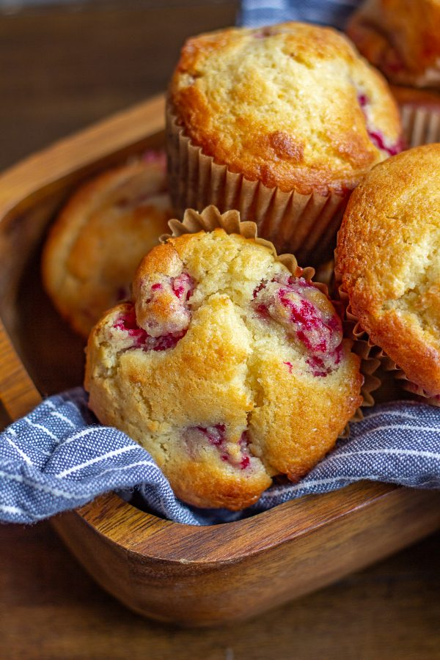

## Ingredients

* 3 tablespoons Butter, softened
* 1/2 cup Whole Milk Ricotta
* 1/2 cup Granulated Sugar
* 1/2 teaspoon Vanilla
* 1 Egg
* 1 Egg White
* 1/3 cup Lemon Curd
* 1/3 cup Fresh Lemon Juice (the juice of 2 Lemons)
* 2 tablespoons Lemon Zest (the zest of 2 Lemons)
* 1 1/4 cup All-Purpose Flour
* 3 teaspoons Baking Powder
* 1/2 teaspoon Baking Soda
* 1/4 teaspoon Salt
* 1/4 cup Milk
* 1 tablespoon Flour for tossing the berries
* 1 1/2 cup Raspberries
* Plus for the topping:
* 1 tablespoon Butter melted
* 1 tablespoon Raw Sugar

## Instructions

Use an electric mixer to combine the butter and ricotta. Once well mixed, add the granulated sugar and mix on a medium high speed until the mixture is fluffy. This will take about 2 minutes.

Add the vanilla, egg, egg white, lemon curd, lemon juice, and 1 tablespoon lemon zest and beat until it is just combined with the butter, ricotta, and sugar mixture.

In a separate bowl, combine 1 1/4 cup flour, with the baking powder, baking soda, and salt.

Remove the bowl of the electric mixer, you want to fold everything together by hand. Fold half of the flour mixture into the wet ingredients. Then fold in the milk and the remaining dry ingredients. Fold together until it is just mixed - don't over mix.

Using the same bowl that contained your dry ingredients, toss the berries in 1 tablespoon flour. Gently fold them into the batter. Then let the batter sit for 15 minutes.

Next, heat your oven to 425 degrees and fill a muffin pan with 12 muffin liners.

Pour the batter into the muffin liners, filling them all the way to the top. Then top with the melted butter, raw sugar, and remaining lemon zest.

Turn your oven light on, and place the muffins in the oven to bake. It will take 10-12 minutes for the muffins to rise and the muffin tops to brown. At this point, reduce the heat to 350 degrees (don't open the oven though). Let bake for another 5-7 minutes.

Remove the muffins from the oven, let cool for 2 minutes, and then place the muffins on their side on a towel to finish cooling. This prevents the muffin tops for sinking as they cool.