**Set dosa recipe**

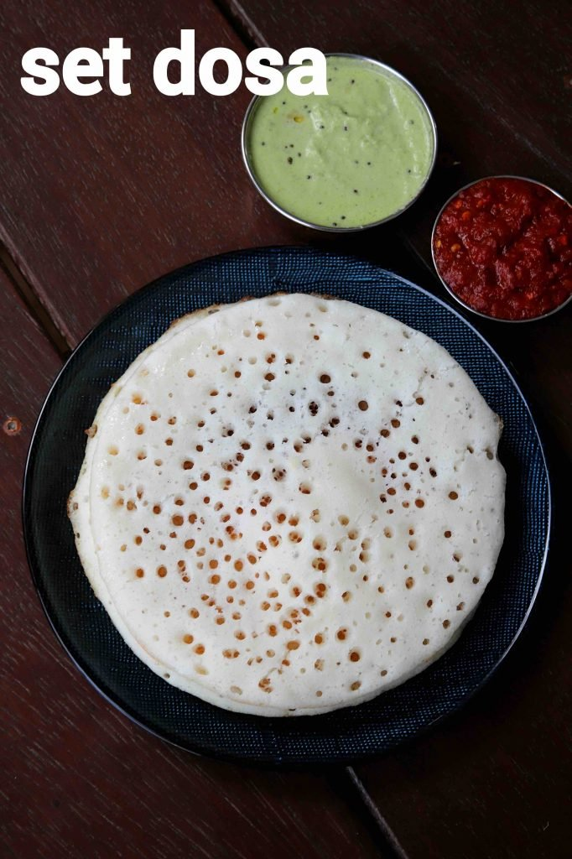

### **INGREDIENTS**

* 2 cup idli rice
* ½ cup urad dal
* ½ tsp methi / fenugreek
* 1 cup poha / aval / flattened rice, thin
* water, for soaking & grinding
* 2 tsp salt
* oil, for roasting

### **INSTRUCTIONS**

* firstly, in a large bowl take 2 cup idli rice, ½ cup urad dal and ½ tsp methi.
* add enough water and soak for 5 hours.
* drain off the water and transfer to the mixi or grinder.
* blend to smooth paste in batches adding water as required.
* in a bowl take 1 cup poha and rinse well.
* blend to smooth paste adding water if required.
* mix the rice-urad dal batter and poha paste well.
* cover and ferment in a warm place for 8 hours.
* after 8 hours, the batter has doubled in size. mix gently without disturbing the air bubbles.
* further add 2 tsp salt and mix well.
* heat the griddle and pour a ladleful of batter.
* spread out in a circular motion slightly thick than regular masala dosa.
* also pour ½ tsp oil around the edges.
* cover and roast the dosa to a golden brown from the bottom and completely cooked from the top in presence of steam.
* finally, enjoy set dosa with chutney.