**Wild Food? It’s Turning Out to be India’s Latest Culinary Love**

Foraging in the wild for edible berries, leaves and fruits is perhaps one of mankind's oldest habits. That, though, does not mean that our habit is rudimentary. Even in the present day and age, hundreds of fringe communities across India rely directly on nature for their daily sustenance. In these areas, the food is not classified into the wild and the supermarket — here, food is about recipes and traditions that have been handed down generations, to give company in times of both crisis and good health.

However, when you enter the charming Bombay Canteen in upstate Lower Parel, Mumbai, foraged or "wild" food is most likely not on your mind. Even if it is, it is unlikely for an average diner to be thoroughly well versed with the rich repository of foraging culture and wild food elements that India, the land of diversity, has. Thomas Zacharias, Executive chef of Bombay Canteen, recently curated and designed a wild food festival for an entire month at his restaurant. As if to serve poetic justice, the idea of promoting wild foods hit Zacharias just the way a rare, wild and succulent berry hits the weary, unassuming traveller trudging along a forest.

"When we opened the Bombay Canteen 4.5 years ago, it was with the target to celebrate the diversity of India," says Zacharias.

"“In a lot of ways, we have evolved as a restaurant over the years. I travel a lot, and have an initiative called #ChefOnTheRoad. Through this, I keep learning constantly, and these inspirations make their way into our menu. A few years ago, I came across a glimpse of wild food, as some of them actually make their way into the Mumbai markets. We use something called ‘moras bhaaji’, which grows in the mangroves of Vashi — it is consumed by the Gujaratis for five days in a year when they are fasting. It is this that made me curious about other wild foods around us.”" - Chef Thomas Zacharias

**Foraging for Food**

Converting curiosity into reality often requires a gentle nudge, which came to Zacharias in the form of a 'Wild food festival' hosted in 2018, organised by OOO Farms — promoters of organic, sustainable agriculture in India. Started by four friends with a passion to conserve nature, promote sustainable living and support India’s treasured cultivators, OOO Farms has gradually grown its presence into a complete ecosystem of creating strategies, providing loans and support, as well as marketing to farmers for indigenous produce. This is bringing to the fore native produce, which many may not have even heard of.

"I was completely blown away, because there was stuff there which I had not even seen in my life, let alone taste it,” says Zacharias. “All of those vegetables came from Maharashtra, and that is when I realised that this was an integral part of our culture and cuisine, and traditions that needed to be told. Ever since then, I had been planning to make this happen at the Bombay Canteen, and we had to do this in the monsoons of 2019, as most of the wild food diversity is available only in the monsoons."

Zacharias, as it seems, is not the only one who picked up on this trend. Noted food historian and archeologist Kurush F. Dalal notes, "The trend is not exactly Indian, and foraging has become a very important movement or revival in the West. The people at the forefront of the foraging movement are advocating it as a lifestyle option, and a sustainable one at that."

Interestingly, Dalal makes a very interesting observation regarding the use of wild food, and what constitutes a part of this culture.

"“Foraged foods were always part of the urban kitchen. Many a foraged green was sold in Mumbai, Thane, Vasai, Nasik etc. during the season of availability, as exotic, much sought-after ingredients — Shevale (Dragons Stalk Yam) and Phodshi. However, these vegetables were being forgotten all over the country, especially in areas closer to the urban centres.”" - Kurush F. Dalal

Initiatives such as those taken by Zacharias are the final straw, in a bid to prevent the rudimentary items from being forgotten, and in fact, ensure that the tribal communities themselves know the worth and richness of their culture. Elucidating on this, Dalal says, "There has been an annual exhibition of these vegetables for the past five years in Thane, and now in Mumbai as of the last two years, where the raw vegetables are on display, and the cooked versions are being served. Wild/foraged foods are found all over India — there are no areas in the country that do not have them. However, the threats to them and the tribal/rural communities from over-consumption and rampant monetisation of these commodities have not been taken into consideration."

**Back to the Roots**

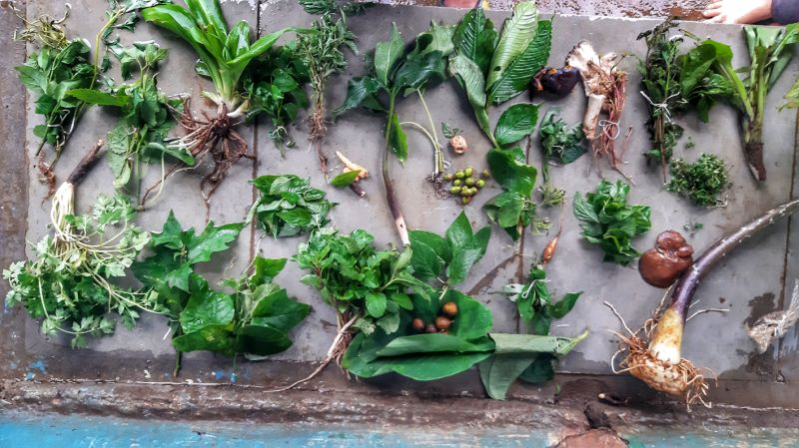

It is this that chefs of influence like Zacharias is out to change. Awate of OOO Farms says, “Today, because of the wild food association with The Bombay Canteen, a successful revenue model has been established between the farmers and the restaurant directly, which gives them a revenue that is significantly bigger than what they earn from their paddy produce, twice a week.”

Zacharias echoes Awate’s sentiments, saying, “Like one of the stories that he narrates to us, "Tribal communities, who’ve been growing vegetables for thousands of years, have slowly shifted to rice and paddy farming in the last 15 years, because they probably have a perception that there is a better life in the plains. So, they started cutting down their forests and started growing rice and wheat, and we took on an initiative to convince them that there is actually a lot of value in what they grow; that they shouldn’t cut down their forests, as they can very well survive on what they grow. That was the seed idea, and from that, it soon evolved into educating the people in Bombay, as these are vegetables that most of them don’t know about."

With such a deep-rooted connect with the soil, foraging and the renewed journey of wild food is a much needed one, and has come along right on cue to revive cultures that may have otherwise been lost in hitherto unkempt pages of history.